**CREDIBILITY OF CLIENTS FOR LOAN APPLICATION**

**Problem Statement:**

In this application, we are basically classifying if the company/bank should give the clients further credits if they request for loan application with the help of past 6 months data regarding their limit balance , past 6 months payment details ,age , gender , education.

**The workflow of this application:**

**Step 1**: The Customer applies for request of loan application to the bank .

**Step 2**: The bank employee now uses this application to check whether this Customer is eligible for loan approval or not.

**Step 3**: The UI page consists of a form in which the Employee will have to enter the Customer_ID and choose which classification algorithm he wants to apply in order to determine the result.

**Step 4**: After the employee presses the submit button, the values submitted in the form is passed into python code. Using the sys package, the python code provided the value given by the employee via filling the form.

**Step 5**: The python code reads the excel sheet and it extracts the important features using rfe model of logistic regression which helps us to determine the features that contribute the most for the required classification.

**Step 6**: Then it trains the model based on the data from the input excel sheet using either of 1) Random Forest Classifier or 2)Logistic Regression classifications models and predicts the classification result according to it .

**Step 7**: The result predicted by the classification models in passed to the UI page where the result gets displayed whether the loan application is granted to the customer or not.

**Screenshots Of The Workflow**:

**UI PAGE**

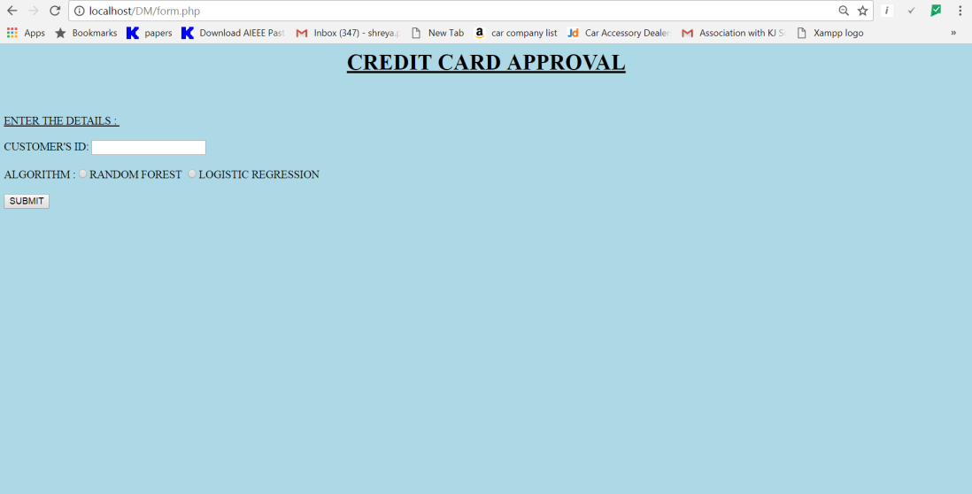

**DATASET**

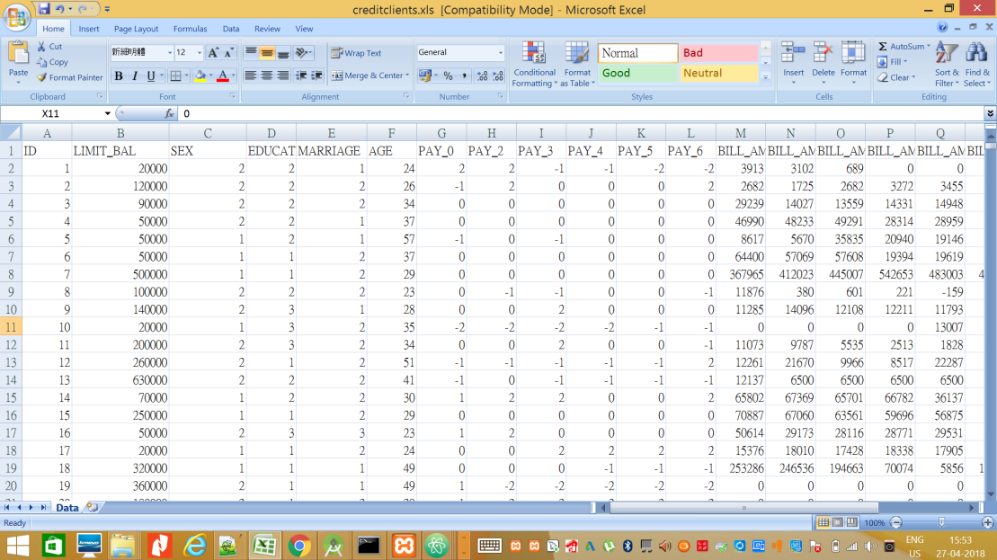

PS: DATASET ATTACHED TO THE REPORT.

**INPUT ID AND SELECT THE ALGORTHM (RANDOM FOREST ALGORITHM)**

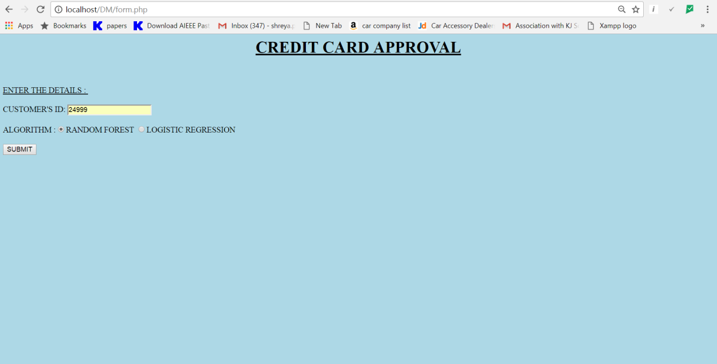

**OUTPUT**

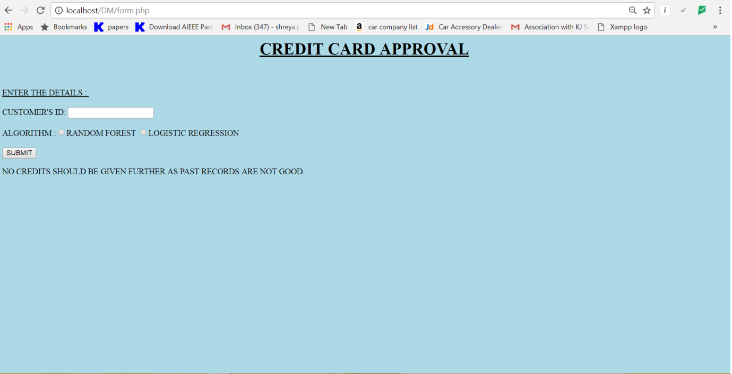

**INPUT ID AND SELECT THE ALGORTHM (LOGISTIC REGRESSION)**

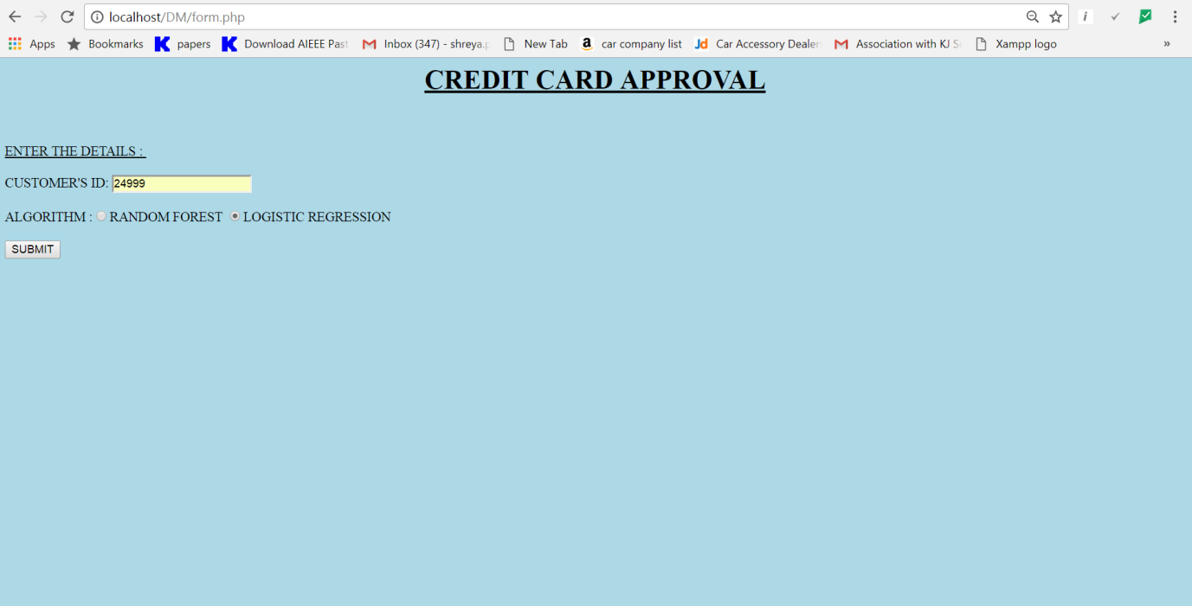

**OUTPUT**



**INPUT ID AND SELECT THE ALGORTHM (RANDOM FOREST ALGORITHM)**

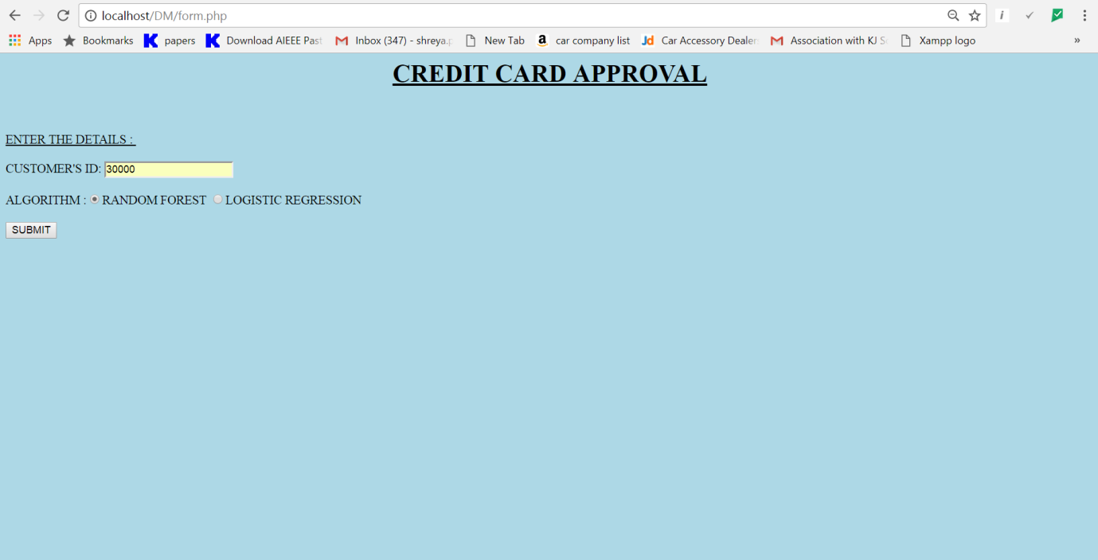

**OUTPUT**

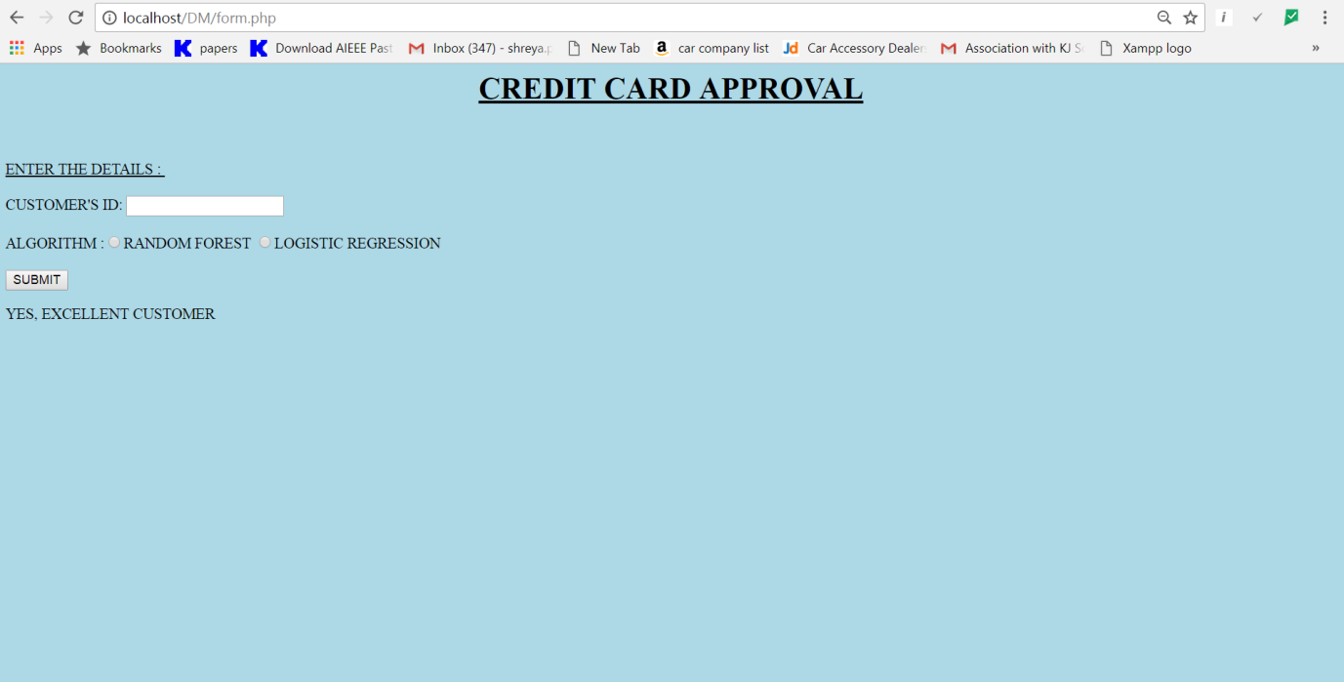

**INPUT ID AND SELECT THE ALGORTHM (LOGISTIC REGRESSION)**

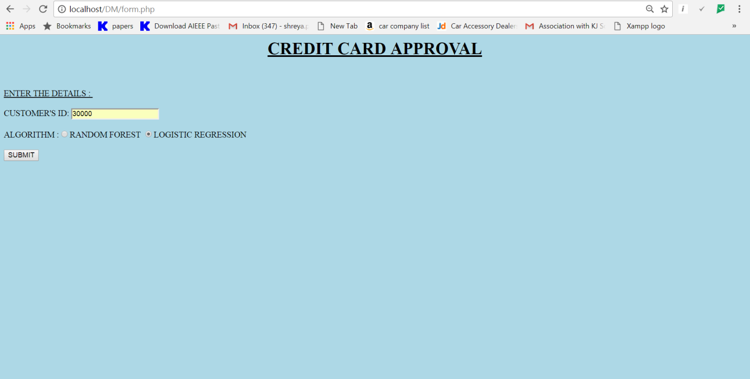

**OUTPUT**



**Question:**

1. Provide Verify accuracy of the mini algorithms using suitable measure.

**Logistic Regression Model (Predictions , Probability and Accuracy)**

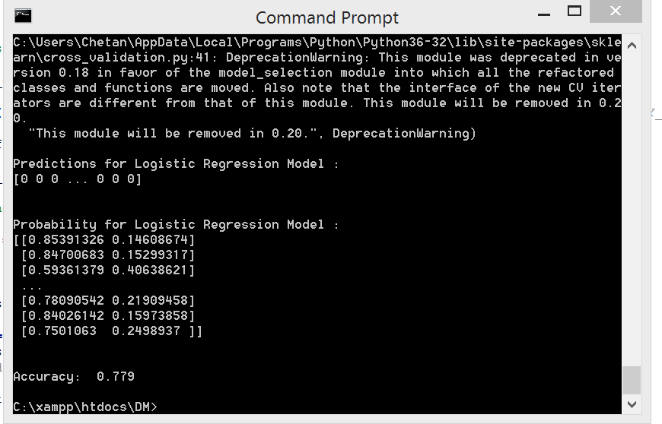

**Random Forest Classifier (Predictions , Probability and Accuracy)**

